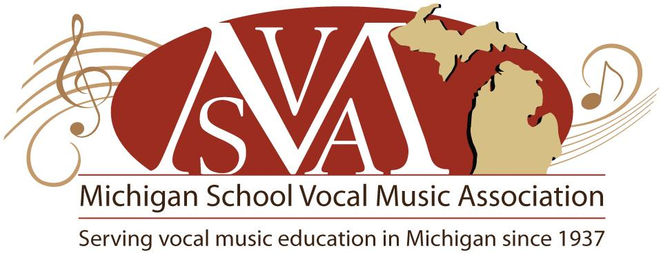
Elizabeth Gray-Roll Co-Manager
St. Joseph Schools
Brett Yzquierdo Co-Manager
Paw Paw Schools

MSVMA District 6 Winter Meeting Agenda
St. Joseph High School
January 11th, 2016
5:00 PM
- Call to order and introductions
Beth Gray-Roll
Carole Conrad
Mary Lynn Edwards
Jocelyn Leonard
Brett Yzquierdo
- Approval of agenda
- Approval of Fall 2015 district Minutes
- Receive treasurer’s report- Brett Yzquierdo
- So far so good. We made a little bit of money on Men’s and JMS Invitational. Just waiting on S&E fees
- Review/reflection of fall events: Middle School Invitational, Men’s Invitational, Musical Theatre Solo and Ensemble, Honors Choir… others?
- Both MS and Men’s Invitational went fine and were a success
- HS Men’s Invite: Some boys weren’t super impressed this year. Music was a little bit easy. Felt like they were singing back up for the invited group, which was a little weird. Boys liked Jed though.
- Musical theatre solo and ensemble: Brett’s kids loved it
- Way less kids than usual did honors choir. Maybe because the song was too hard to memorize?
- Jocelyn took her kids to Chamber Music Festival and she loved it. She felt like they got so many great literature ideas. Very cool to watch the other choirs.
- Review Festival/Solo and Ensemble registration and deadlines
- HS S&E registration deadline Wednesday 1/13
- Festival registration deadline 1/23
- Review guidelines for festival/Solo and Ensemble
- Guidelines are online
- Proposed dates for 2017
MS Solo & Ensemble
    - Date – April 22nd, 2017
    - Location– Lakeshore Middle School
    - Host –Carole Conrad
HS Solo & Ensemble
    - Date – February 11th, 2017
    - Location – Southwestern Michigan College
    - Host – David Carew
MS Choral Festival
    - Date – February 21st and 22nd or February 28th and March 1st
    - Location – The Chapel
    - Host – Katie Rohwer
HS Choral Festival
    - Date – February 21st and 22nd or February 28th and March 1st
    - Location – The Chapel
    - Host– Katie Rohwer

- 2016 SR Books will be sold after District Festival $2.50/book
- Other Business/Celebrations/Resources
- Sight reading CD with multiple examples
- Lets put our program from festival on our webpage so people can see what type of literature other people are doing.
- Proposals to be talked about at full board meeting
- Blog instead of Journal: No strong opinions
- Remove memorization requirements: If the song selection was appropriate, it wouldn’t be an issue to memorize
- Realignment of festival final determinations: Strongly support bringing back numbers. Kids/administrators think of it that way any way.
- Return to previous performance rubric: … undecided
- 6-7-8-9- Honors choir auditions individual basis: YES
- SSA Auditions may include SA or SS auditions only: YES

- Set date for Spring Meeting
- 5/9 @5 pm @ Coaches
- Adjournment

