Tamara Grove Williams  District 2 Co-Manager  TC Central High School  1150 Milliken Drive  Traverse City, MI 49686  williamsta@tcaps.net  (231) 933-3571 | 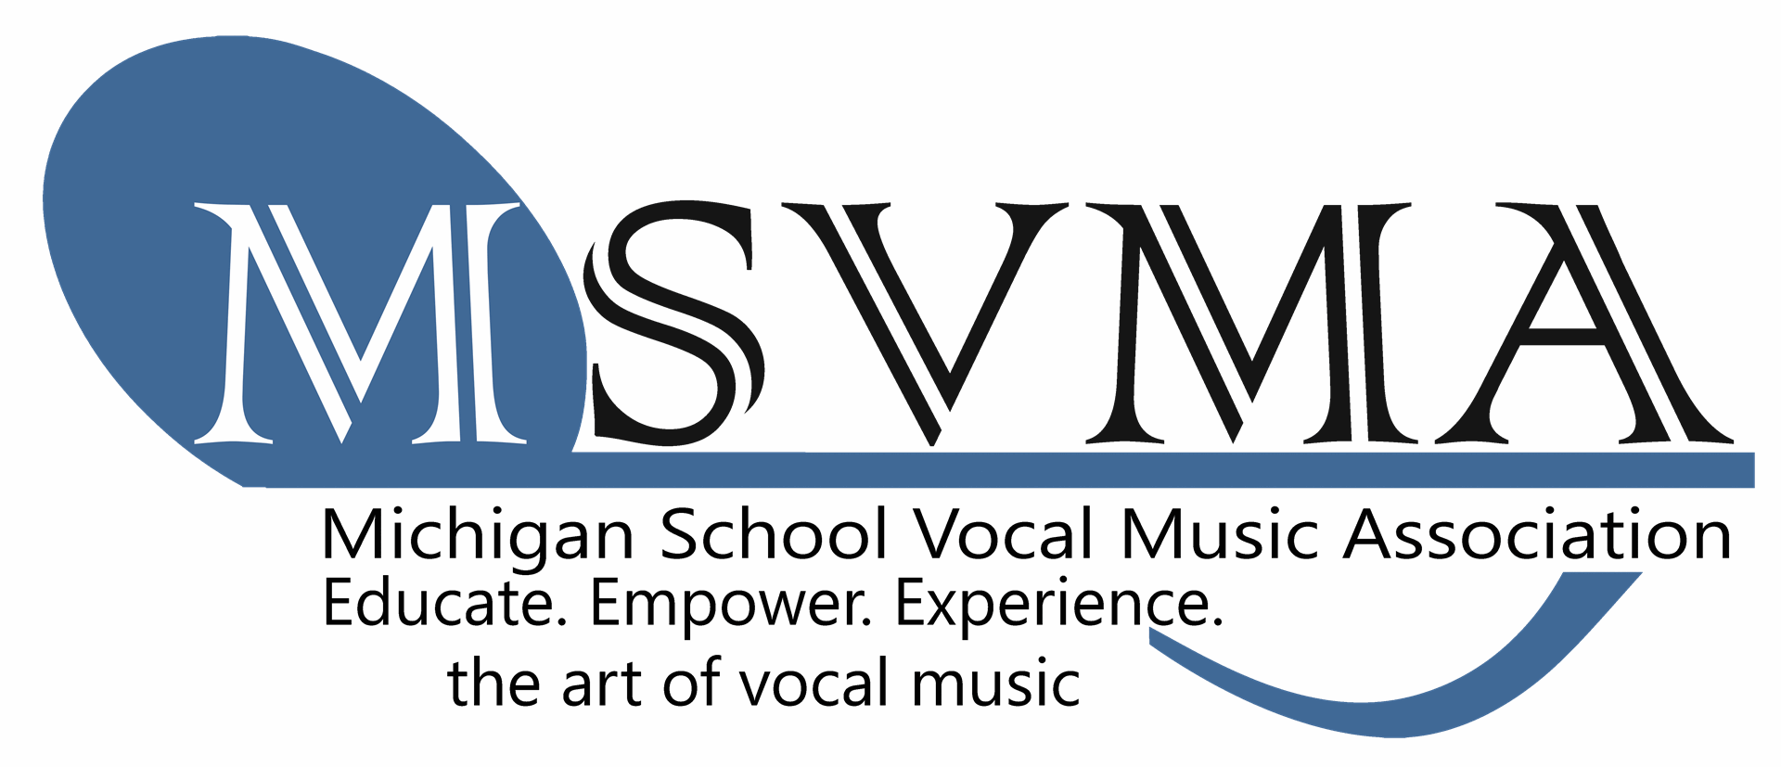 | Michele Zebell  District 2 Treasurer  TC East Middle School  1776 North 3 Mile Road  Traverse City MI 49696  zebellmi@tcaps.net  (231) 933-7320

DISTRICT 2 Spring Meeting
April 21, 2016

AGENDA

PRE-MEETING: Dinner, Introductions & Celebration

- Call to order and introductions: Present: Grove-Williams, Wolf-Schlarf, Dee, Case, Zebell, Wills
  - Absent: Carter, Evans, Evans, Stow, Reed, Ross, Wells, Saunders, Stokes,
Puchala, Wangeman
- Approval of today’s agenda
- Approval of FALL 2015 meeting minutes
- MSVMA January Full Board meeting update: Christy Case
- Proposals from January: New Classification for Rubric – all “Excellent” and “1” ratings (no “Superior”).
- Receive treasurer’s report: Michele Zebell
- Report on District 2 Festivals 2016
  - HS/MS Solo & Ensemble: Tamara Williams, Michele Zebell, Wendee W-S, Emerick Dee
  - Next Year – Courtyard Inn for Judges, West parent, Mrs. Matthews
  - We lost $600 at S&E
  - Request an ensemble judge who will also take solos to save $
  - Gaylord site - Choral Festival: Justin Reed, Chris Hodges
  - TC site - Choral Festival: Tamara Williams/ Michele Zebell

- Festival dates for 2017
  - MS/HS Solo & Ensemble
    - Date : January 28, 2017
    - Location– TC West HS
    - Host –Erich Wangeman/ Wendee Wolf-Schlarf
  - MS/HS Choral Festival Day 1
    - Date : Tues, Feb. 28, 2017
    - Location –TBD
    - Host – TBD
  - MS/HS Choral Festival Day 2
    - Date : Wed, Mar. 1, 2017 (also MSBOA Festival) – we may not need this date if TCAPS groups do not participate.
    - Location –TBD
    - Host– TBD

- Festival dates for 2018 to present at the District Managers Workshop this summer …
  - MS/HS Solo & Ensemble
    - Date : January 27, 2018
    - Location– TBD
    - Host –TBD
  - MS/HS Choral Festival Day 1
    - Date : Feb. 27, 2018
    - Location –TBD
    - Host – TBD
  - MS/HS Choral Festival Day 2
    - Date : Feb. 28, 2018
    - Location –TBD
    - Host– TBD

- State nominations:
  - MS Honors Choir Directors (MMC 2019)
    - (6-7-8, SA) Michele Zebell
    - (7-8-9, SSA) Stephanie Schall-Brazee
    - (7-8-9, TTB) Erich Wangeman (declined)
  - HS Honors Choir Directors (MMC 2019)
    - (SSAA) Lindsay Wills
    - (TTBB) Erich Wangeman (declined)
    - (SATB) Russ Larimer (declined)
  - Teacher of the Year (2017)
    - Erich Wangeman
  - Emeritus Membership

- District 2 concerns to be presented at the June Full Board Meeting
  - Low participation in District 2 – is it possible to combine districts? Maybe another small District like D1 ? (Cadillac, Big Rapids, McBain, Ludington)

  - DISTRICT CHORAL FESTIVAL: Conversation with TCAPS schools/directors not participating; potential for a 1-day Festival in Gaylord if enough schools want to participate. Others could also transfer to another District festival.

  - Having trouble paying for hotels, etc. with checks. Any chance in revisiting the credit card option for MSVMA District Managers?

  - Other schools in our district that could be participating? Charlevoix, Harbor Springs, Home school association? How can we reach out to these programs?

- Other Business
  - District 2 Co-Manager for 2016-2017 - nominations and vote

  - Next Meeting
    - Date: September 22 , 2016
    - Location: Minerva’s Restaurant – Traverse City, MI, 6:00 p.m.
    - Save the date: Spring meeting April 20, 2017

- Adjournment

